Exception Handling
─

Contents
1. What are Exceptions 2
# Hierarchy of Java Exceptions 2
2. Throwing and Catching Exceptions 4
# try, catch and finally 4
# throw vs throws 4
# Multiple Catch block 5
# Nested Exception Handling 6
2. Exception Propagation 7
# For Unchecked exceptions 7
# For checked exceptions 7
# Exception Chaining 8
# Best Practices for Exception Propagation 9
4. Exception Classes, Methods and Custom Exceptions 12
# Custom Checked Exception 12
# Custom Unchecked Exception 13

1. What are Exceptions
An exception is an abnormal event that occurs during the execution of a program that disrupts the normal flow of the program.
Eg:
public class Main {
public static void main(String[] args) {
System.out.println("Start");
int result = 10 / 0;
System.out.println("End");
}
}

The program compiles successfully, but at runtime:
Start
Exception in thread "main" java.lang.ArithmeticException: / by zero
End is never printed. The exception has interrupted the normal execution flow.

Exception handling provides:
- controlled handling of failures
- meaningful error messages
- recovery where possible
- resource cleanup
- propagation of failures to appropriate layers
- separation between normal logic and error-handling logic

# Hierarchy of Java Exceptions
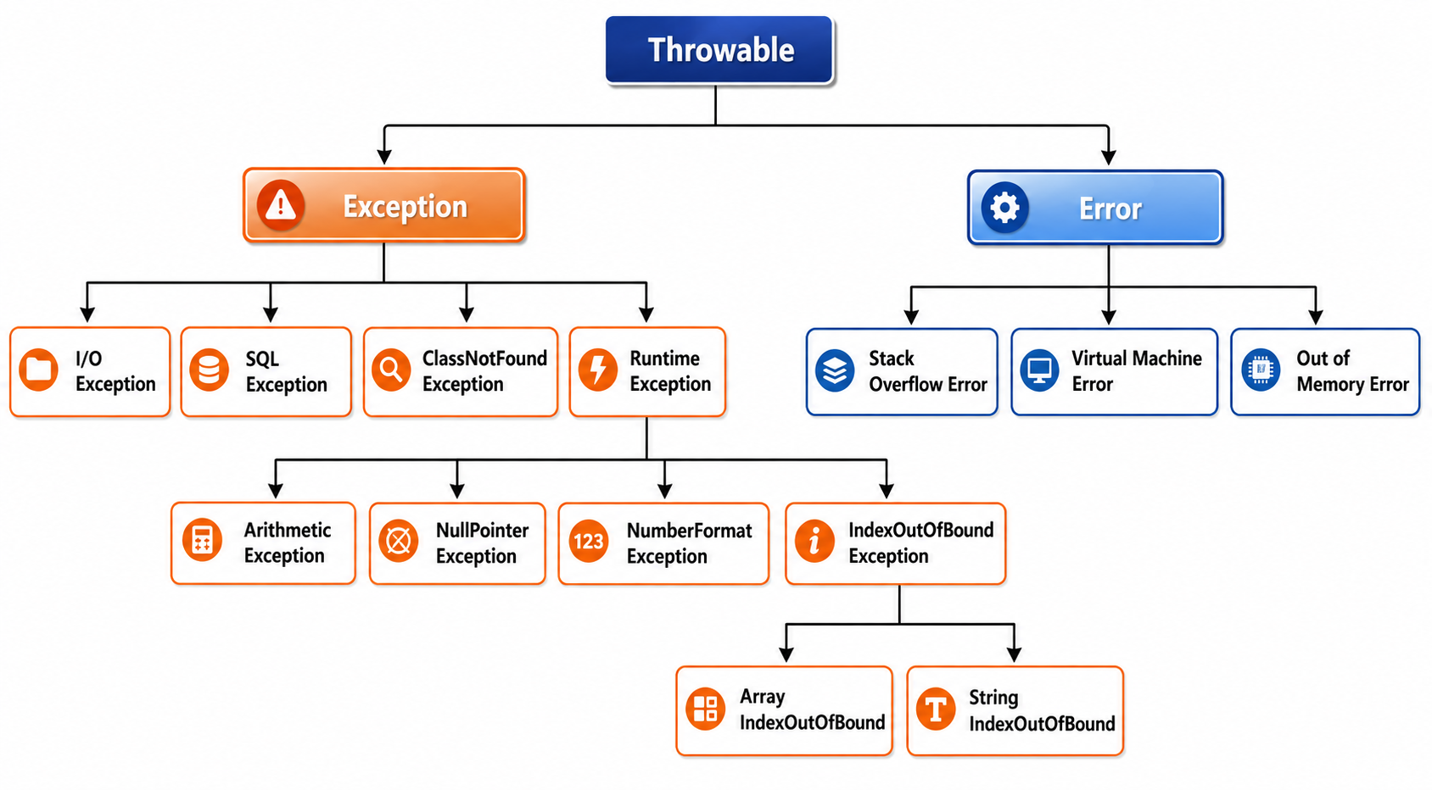

Throwable is the superclass of both Error and Exception. Only Throwable and its subclasses can be thrown using Java's throw mechanism.
Compile time exception (checked exception):
- Exceptions that are checked at compile time.
- The program will not compile unless they are handled or declared.
- Examples: IO Exception, SQLException

import java.io.File;
import java.io.FileReader;
public class CheckedExceptionExample {
public static void main(String[] args) {
try {
File file = new File("nonexistent.txt");
FileReader reader = new FileReader(file);
} catch (Exception e) {
System.out.println("File not found: " + e.getMessage());
}
}
}

Run time exception (unchecked exception):
- Exceptions that occur during the execution of a program.
- They are not checked by the compiler.
- Examples: NullPointerException , ArithmeticException

public class UncheckedExceptionExample {
public static void main(String[] args) {
String str = null;
System.out.println(str.length()); // Causes NullPointerException
}
}

Error:
- Represent serious problems that the application cannot recover from.
- Examples: OutOfMemoryError, StackOverflowError
public class StackOverflowErrorExample {
public static void recursiveMethod() {
recursiveMethod(); // Infinite recursion
}
public static void main(String[] args) {
recursiveMethod();
}
}

2. Throwing and Catching Exceptions

# try, catch and finally

- try: Put potentially problematic code inside try. A try statement must be followed by at least one catch or a finally block.
- catch: handles an exception.
- finally: primarily used for cleanup. Normally, finally executes whether the try block completes normally or exceptionally. Cleanup normally executes before the exception continues propagating.

try {
System.out.println("Try");
//main code
}
catch (Exception e) {
System.out.println("Catch");
//code to handle exception
}
finally {
System.out.println("Finally");
//cleanup code
}

# throw vs throws

- throw: explicitly throw an exception.

if (age < 18) {
throw new IllegalArgumentException(
"Age must be at least 18"
);
}

- throws: appears in a method declaration. It tells the called code that the method may propagate the specified exception

public void validate(int age) throws InvalidAgeException {
if (age < 18) {
throw new InvalidAgeException(
"Age must be 18 or above"
);
}
}

Throw:
- Used to explicitly throw an exception (either checked or unchecked).
- Requires an instance of Throwable (or its subclass) using the new keyword.
- Typically used inside a method or block.
- Only one exception can be thrown at a time.
- It is a statement
- Eg: throw new ArithmeticException("Divide by zero");
Throws:
- Used to declare exceptions in the method signature.
- Tells the compiler that the method may throw an exception.
- Mainly used for checked exceptions (like IOException, SQLException).
- Can declare multiple exceptions, separated by commas.
- It is a declaration
- Eg: public void readFile() throws IOException, SQLException {}

# Multiple Catch block

You can handle different exceptions differently.

try {
// risky code
}
catch (ArithmeticException e) {
System.out.println("Arithmetic problem");
}
catch (NullPointerException e) {
System.out.println("Null problem");
}
catch (Exception e) {
System.out.println("Other exception");
}

Catching order is important, below code is wrong as IOException is child of Exception. So IOException code is never really executed.
try {
}
catch (Exception e) {
}
catch (IOException e) {
}

General Rule of multiple catch blocks: Specific exception -----> more general exception

Multi-Catch
Java allows several unrelated exceptions to be handled together:
try {
// code
}
catch (IOException | SQLException e) {
System.out.println("Operation failed");
}

This is useful when handling logic is identical.
But this is invalid: catch (Exception | IOException e) Because IOException is already a subtype of Exception.

# Nested Exception Handling

try {
try {
int x = 10 / 0;
} catch (ArithmeticException e) {
System.out.println("Inner handler");
}
} catch (Exception e) {
System.out.println("Outer handler");
}

The inner handler gets the first opportunity to handle the exception.

2. Exception Propagation
Exception propagation is the process where an unhandled exception automatically moves up the call stack from the current method to its caller until a matching catch block is found; for checked exceptions, each intermediate method must handle or declare the exception.

# For Unchecked exceptions

Consider code:

public static void main(String[] args) {
methodA();
}
static void methodA() {
methodB();
}
static void methodB() {
methodC();
}
static void methodC() {
int x = 10 / 0;
}

Call stack is: main()
↓
methodA()
↓
methodB()
↓
methodC()

For unchecked exception: Propagation happens automatically. throws is optional.

So in above code, exception (Arithmetic exception – unchecked) occurs methodC(). If methodC() doesn’t handle it, Java looks for handler in methodB() then methodA() then main(). This process is called exception propagation.

If nobody handles it, the thread terminates and the JVM's default exception handling mechanism prints the exception information and stack trace.
To manually print stack trace use: e.printStackTrace().

# For checked exceptions

For checked exception, we have to either handle it in that method, or propagate to parent call.
Eg: methodC() throws a checked exception:

static void methodC() throws IOException {
throw new IOException();
}

Now Java says: IOException is checked, so whoever calls methodC() must either handle it or declare it.

Therefore, methodB() cannot simply do:

static void methodB() {
methodC(); // ❌ compilation error
}

It must either handle it, or propagate it further using throws:

//handles the error
static void methodB() {
try {
methodC();
} catch (IOException e) {
System.out.println("Handled");
}
}
// Propagates further
static void methodB() throws IOException {
methodC();
}

Notice that throws does not handle the exception.
It simply says:
"I am not handling this exception here; let my caller deal with it."

# Exception Chaining

Exception chaining means throwing a new, more meaningful exception while keeping the original exception attached as its cause.

Suppose a repository encounters: SQLException
But the service layer wants to expose: UserServiceException
Instead of losing the original exception:
catch (SQLException e) {
throw new UserServiceException(
"Unable to retrieve user"
);
}

If you print stacktrace: This only prints:
UserServiceException: Unable to retrieve user
at UserRepository.getUser(UserRepository.java:10)
at UserService.processUser(UserService.java:20)
….

You don't know why retrieving the user failed.
With Exception chaining:

catch (SQLException e) {
throw new UserServiceException(
"Unable to retrieve user", e
);
}

Stacktrace will say:
UserServiceException: Unable to retrieve user
at UserRepository.getUser(UserRepository.java:10)
at UserService.processUser(UserService.java:20)
at Main.main(Main.java:5)

Caused by: java.sql.SQLException: Connection refused
at UserRepository.fetchUserFromDatabase(UserRepository.java:7)
at UserRepository.getUser(UserRepository.java:8) ... more stack trace

This tells the higher layer/business code what went wrong from its perspective. And also tells the developer/operations team what the actual technical root cause was.

# Best Practices for Exception Propagation

Core rule: Catch an exception only when you can meaningfully handle or recover from it; otherwise, propagate it to a layer that can make the right decision.

- Propagate when the current method cannot meaningfully handle the exception
If methodC() cannot recover from the failure, let the caller handle it instead of blindly catching it.
- Handle exceptions at the right layer
Handle an exception where you have enough context to make a meaningful decision. For example, a database layer may propagate SQLException, while a service/controller layer may convert it into an appropriate business or API response.
- Don't catch just to log and continue
Avoid:
catch (Exception e) {
log.error("Error", e);
return null;
}
This can hide the real problem and cause failures later.
- Don't use throws unnecessarily for unchecked exceptions
RuntimeException and its subclasses automatically propagate. You generally don't need:
void method() throws NullPointerException
- For checked exceptions, either handle or propagate intentionally
If you cannot recover:
void methodC() throws IOException {
// operation
}

Don't catch a checked exception merely to avoid writing throws.
- Preserve the original exception when wrapping it
If you want to throw a more meaningful exception, use the original exception as the cause:
catch (SQLException e) {
throw new UserServiceException("Unable to fetch user", e);
}
This preserves the original stack trace and root cause.
- Don't catch Exception unless you have a specific reason
Prefer:catch (SQLException e)
over:catch (Exception e)
Broad catches can hide programming errors.
- Don't silently swallow exceptions
This is usually bad:
catch (IOException e) {
// do nothing
}
If you catch it, either recover, handle, transform, or deliberately rethrow it.

Eg Scenario: Catching an Exception Too Early

static User getUser() {
try{
return fetchUserFromDatabase();
}
catch (SQLException e) {
System.out.println("Database error: " + e.getMessage());
return null;
}
}

Above method is used by methodB()

static void methodB()
{
User user = getUser();
System.out.println(user.getName());
}

What’s wrong? getUser() catches the SQLException, logs it, and returns null.
The problem is that the database operation failed, but methodB() doesn't know that it failed. It assumes it received a valid User and executes: user.getName();
This can cause a NullPointerException, hiding the original database problem.

Correct Approach: If getUser() cannot recover from the database failure, let the exception propagate:

static User getUser() throws SQLException {
return fetchUserFromDatabase();
}
static void methodB() throws SQLException {
User user = getUser();
System.out.println(user.getName()); // won’t run when getUser has exception, so no NullPointerException
}

Then a higher-level layer that knows how to respond to the failure can catch it:

try {
methodB();
} catch (SQLException e) {
// Return appropriate error / fallback response
}

Core: Don't catch an exception merely to prevent propagation. Catch it where you can actually handle the failure meaningfully.

4. Exception Classes, Methods and Custom Exceptions

# Custom Checked Exception

Create a checked custom exception when the failure is a known, recoverable business/application condition and you want to force the caller to consciously handle it.
- InsufficientBalance
- InvalidLoanAmount
- SeatNotAvailable
- InsufficientInventory

Basic example:
class InsufficientBalanceException extends Exception {
public InsufficientBalanceException(String message) {
super(message);
}
}

Used as
public void withdraw(double amount) throws InsufficientBalanceException {
if (amount > balance) {
throw new InsufficientBalanceException("Insufficient balance");
}
}

Note: super(message) should be first statement in the constructor. Else will get compilation error.
public InsufficientBalanceException(String message) {
System.out.println(message);
super(message); // ❌ compilation error
}

Example 2: Adding Additional fields
This is where custom exceptions become useful.

class InsufficientBalanceException extends Exception {
private double balance;
private double requestedAmount;
public InsufficientBalanceException(String message, double balance, double requestedAmount) {
super(message);
this.balance = balance;
this.requestedAmount = requestedAmount;
}
public double getBalance() {
return balance;
}
public double getRequestedAmount() {
return requestedAmount;
}
}
Used as:
throw new InsufficientBalanceException(
"Insufficient balance",
5000,
8000
);

This exception now carry more details. To print in some other structure, we can override toString() in exception class
@Override
public String toString() {
return "InsufficientBalanceException: " +
getMessage() +
", balance=" + balance +
", requestedAmount=" + requestedAmount;
}

Now System.out.println(e) gives:
InsufficientBalanceException: Insufficient balance, balance=5000.0, requestedAmount=8000.0

Java automatically knows about message because Throwable provides it. Your custom fields are only available through the fields/getters/toString that you define.

# Custom Unchecked Exception

Use a custom unchecked exception (extends RuntimeException) when you want to represent an application/business failure without forcing every caller to catch or declare it.
Use when problem represents:
- invalid input
- invalid state
- programming error
- violation of an API contract

Examples:
- UserNotFoundException
- OrderNotFoundException
- ProductNotFoundException
- InvalidOrderStateException
- DuplicateUserException
- PaymentFailedException
- UnauthorizedException
- InvalidAmountException

This are created same as custom checked exception, but here they just extends RuntimeException

class InvalidTransactionException extends RuntimeException {
public InvalidTransactionException(String message) {
super(message);
}
}

For them, propagation happens without throws. Just like for other runtime exceptions

Checked | Unchecked
extends Exception | extends RuntimeException
Caller must handle/declare | Caller doesn't have to handle/declare
Good when caller is expected to consciously recover | Good when handling is centralized or propagation is preferred
More explicit | More flexible
Can make method signatures verbose | Cleaner method signatures

Does the caller at this level need to be forced by the compiler to handle this exception?
- If yes → checked.
- If no, let it propagate to an appropriate higher-level handler → unchecked.

For Interview Questions, Check Out:
https://github.com/PALASH-BAJPAI/Java-beginner-to-advance/tree/main/Interview%20Questions

